Operate with Turtlebot3

When you read this tutorial we assume that you have already installed ROS and read the General lessons!

Starting turtlebot3 in Gazebo simulation
There are three models of the turtlebot3 robot: burger, waffle and waffle_pi
In each new terminal must be set the used model, so when a new terminal is opened complete the following command:
For burger: export TURTLEBOT3_MODEL=burger
For waffle: export TURTLEBOT3_MODEL=waffle
For waffle_pi: export TURTLEBOT3_MODEL=waffle_pi
Open new terminal and follow the instructions:
- Start the simulation in empty world:
roslaunch turtlebot3_gazebo turtlebot3_empty_world.launch

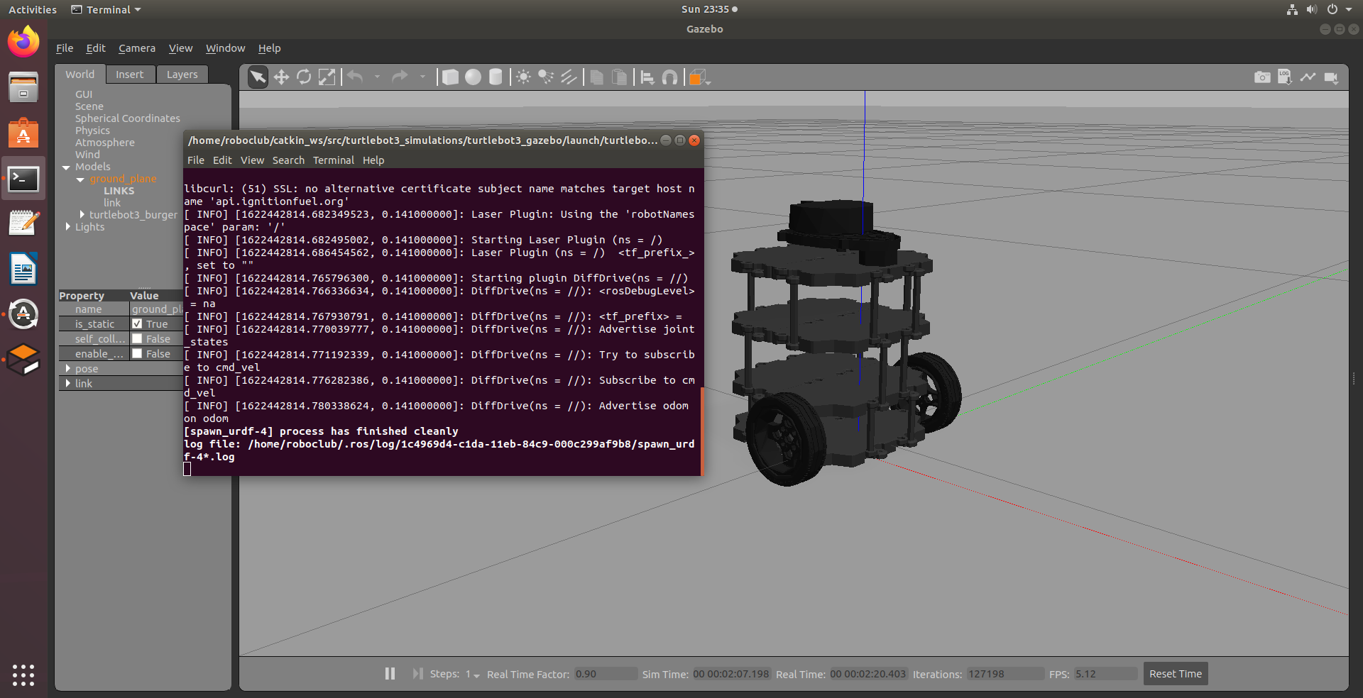

- Start the simulation in TurtleBot3 World
roslaunch turtlebot3_gazebo turtlebot3_world.launch

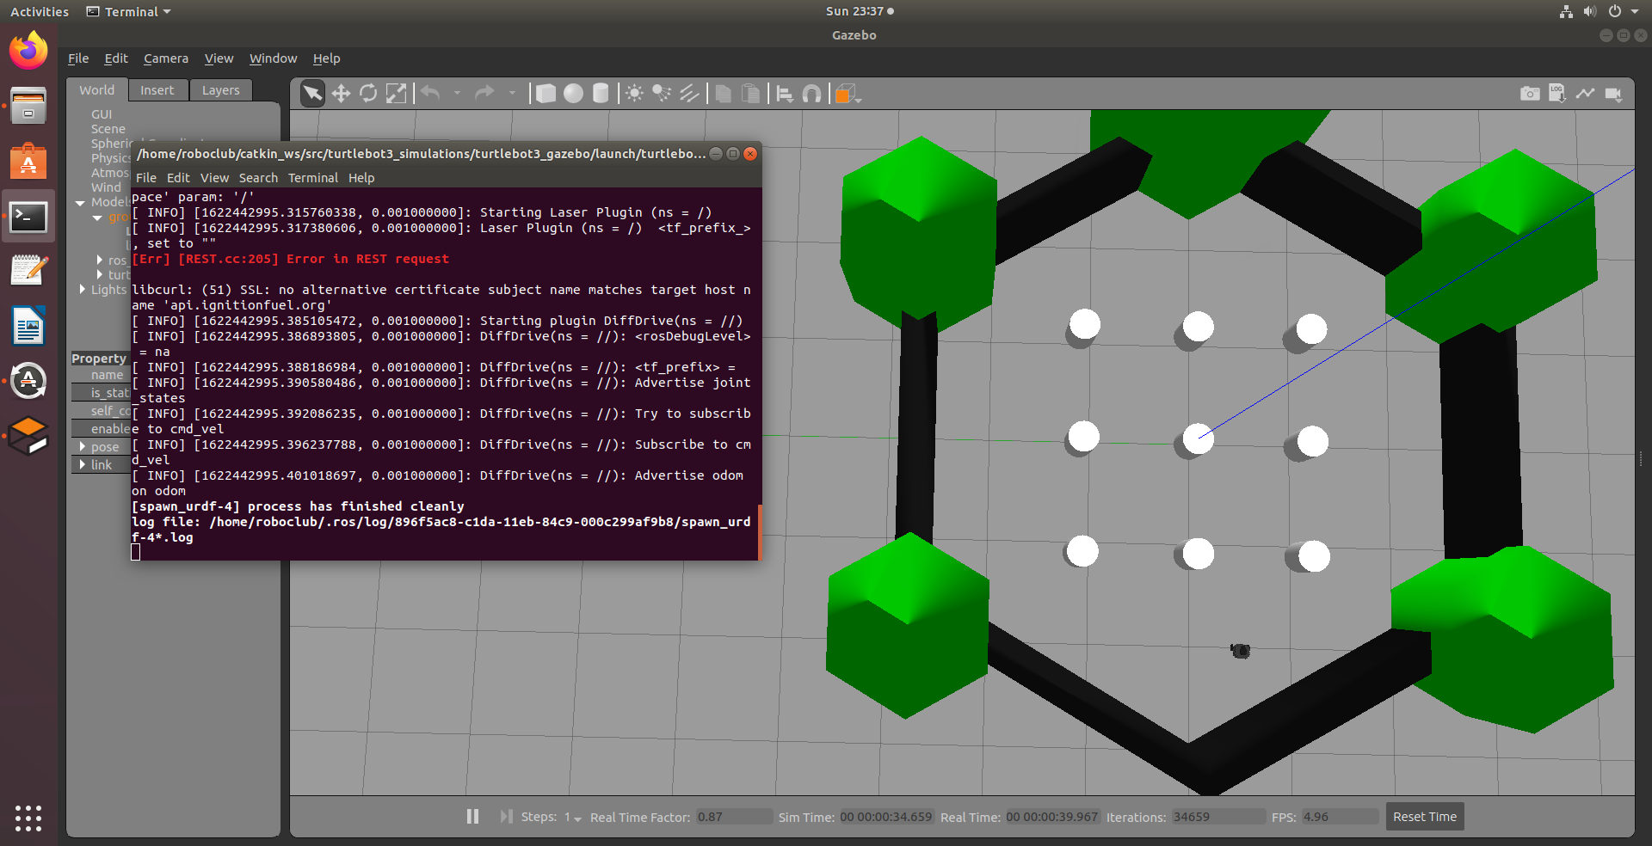

- Start the simulation in TurtleBot3 House
roslaunch turtlebot3_gazebo turtlebot3_house.launch

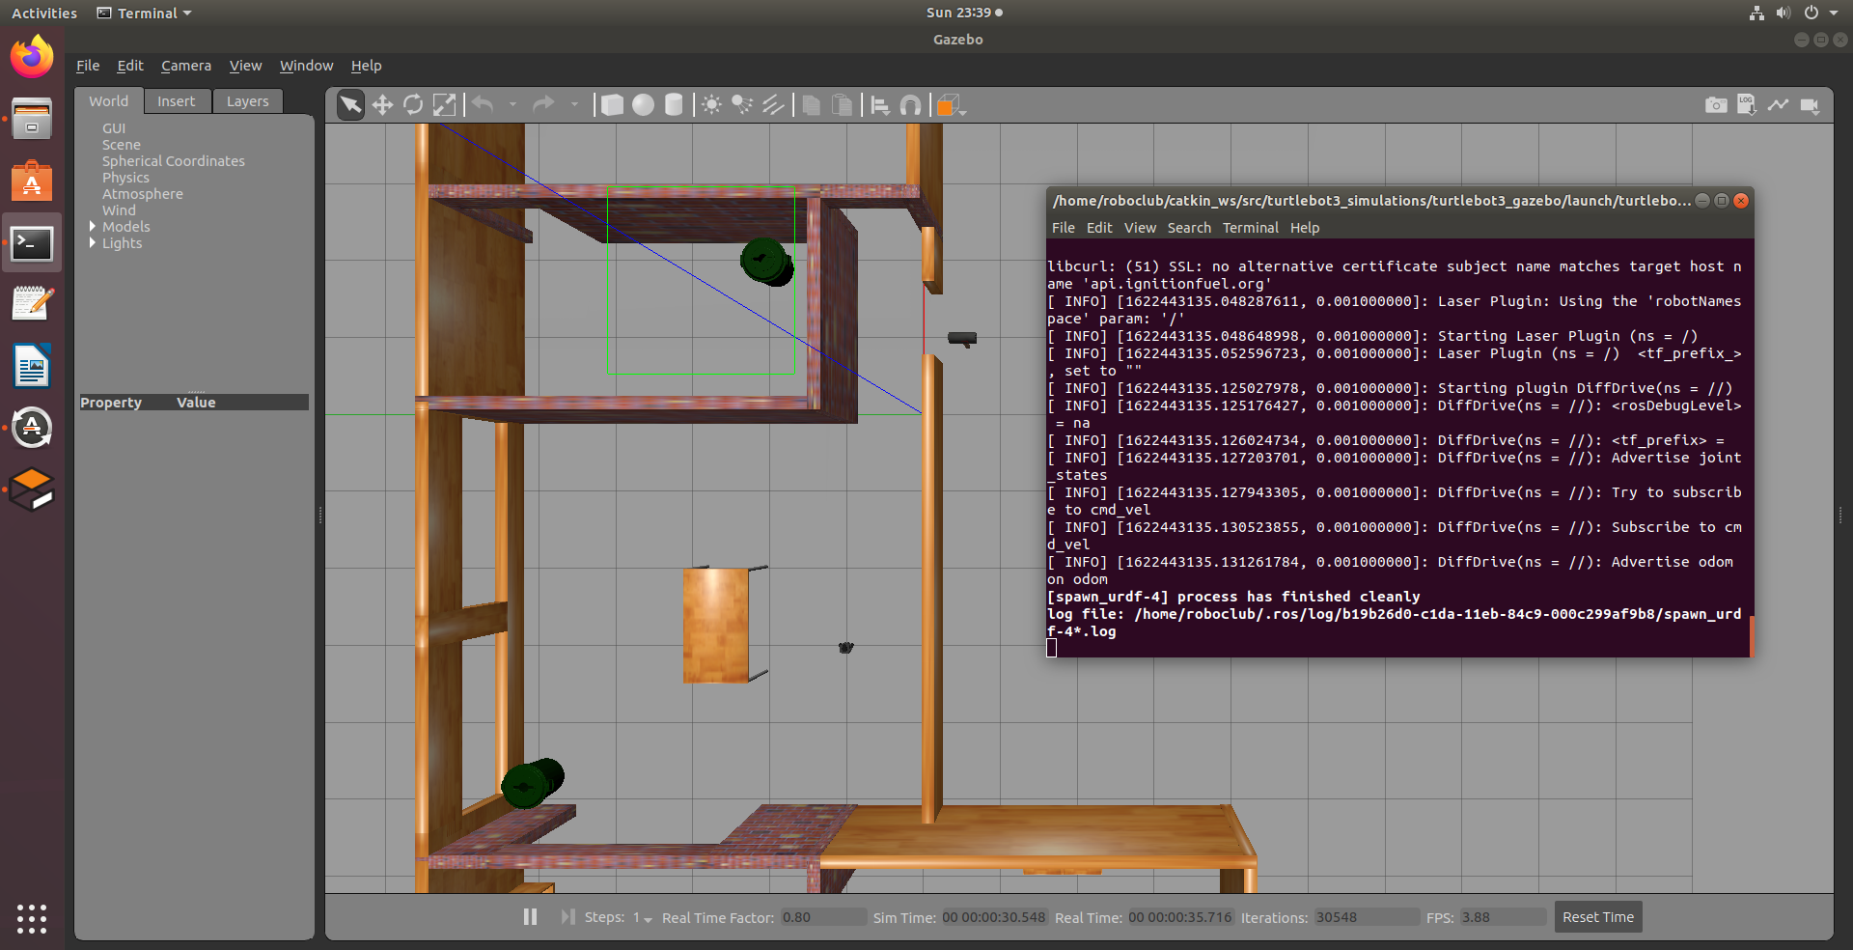

Each different simulation must be started separately. When you want to start a new simulation, terminate all other simulations.
To terminate the simulation, open its terminal and type the Ctrl+C combination
When the robot is started in simulation environment, we can control it by keyboard

Move the robot in the simulation
In order to tele-operate the TurtleBot3 with the keyboard; launch the teleoperation node with below command in a new terminal window.
First, enter the chosen robot model and then start the node:
export TURTLEBOT3_MODEL=burger
roslaunch turtlebot3_teleop turtlebot3_teleop_key.launch

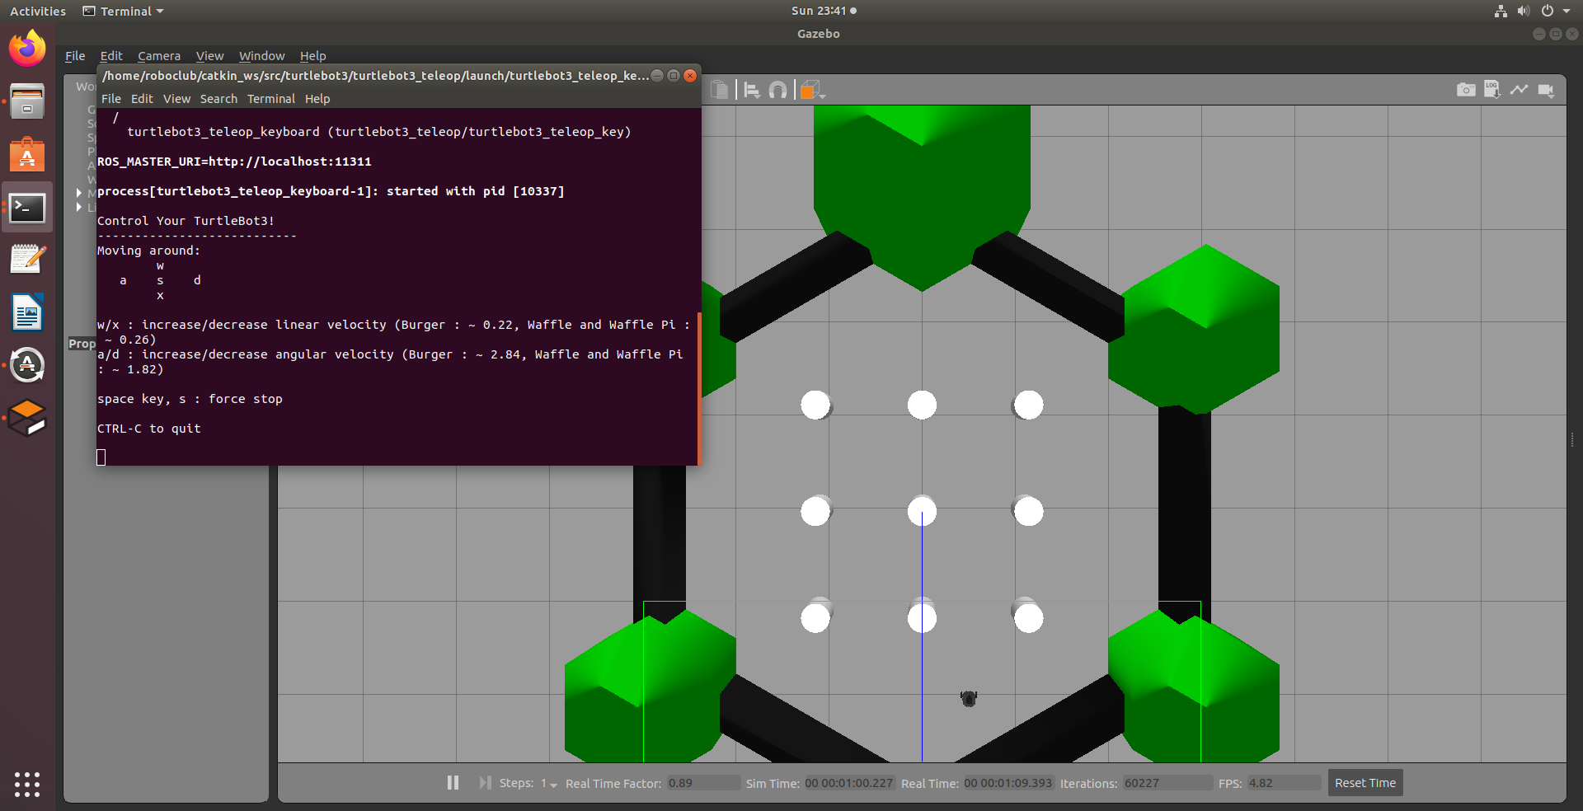

To terminate the teleop node enter the Ctrl+C in the terminal that run that node.
Visualize simulation data in Rviz
RViz visualizes published topics while simulation is running. You can launch RViz in a new terminal window by entering below command.
roslaunch turtlebot3_gazebo turtlebot3_gazebo_rviz.launch

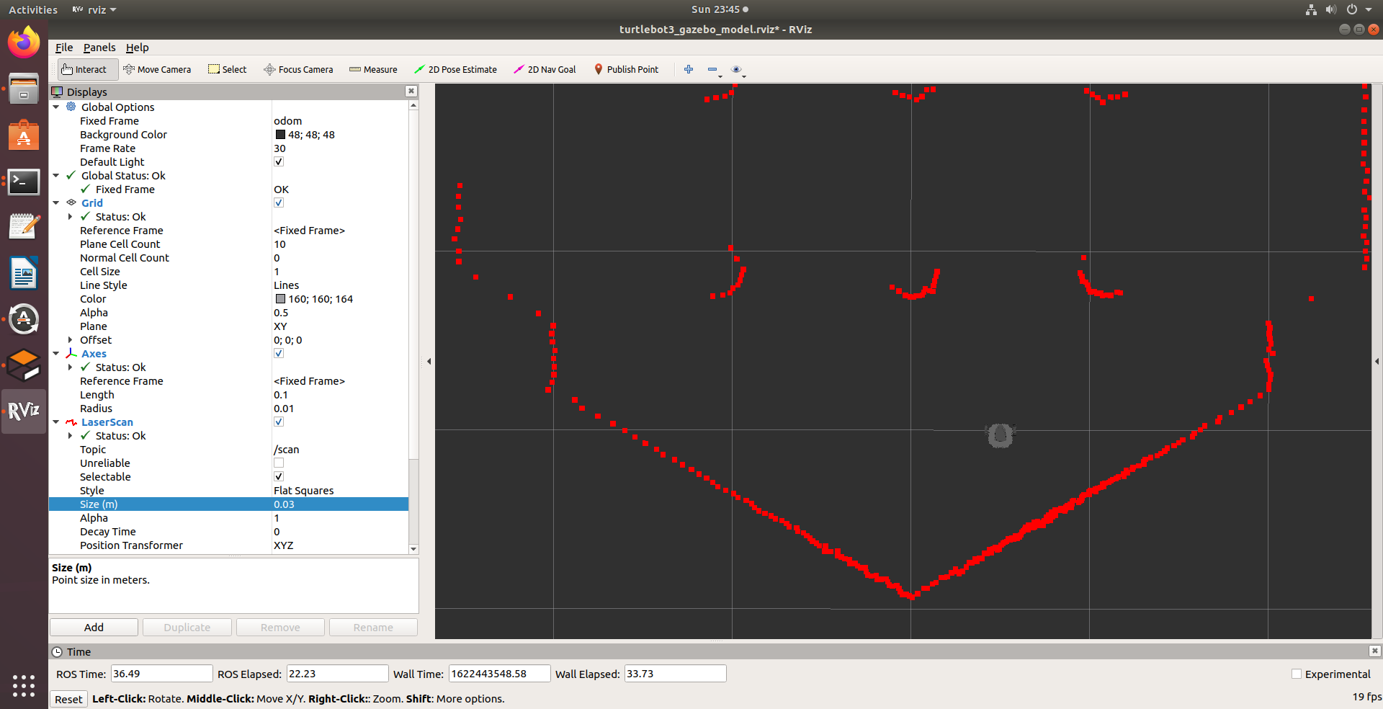

To terminate the RViz node enter the Ctrl+C in the terminal that run that node.

SLAM simulation
If you have running applications in terminals, terminate all applications in all terminals with Ctrl+C.

This simulation is used for map creation. It is recommended to use TurtleBot3 World or the TurtleBot3 House simulation environments. For the robot model, the requirement is to use the same model in each new terminal.
The given example is using turtlebot3 burger model and for both sim environment.
- Start the simulation:
export TURTLEBOT3_MODEL=burger
roslaunch turtlebot3_gazebo turtlebot3_world.launch
- Run SLAM node
Open new terminal and enter the commands:
export TURTLEBOT3_MODEL=burger
roslaunch turtlebot3_slam turtlebot3_slam.launch slam_methods:=gmapping
- Run Teleoperation node
Open new terminal and enter the commands:
export TURTLEBOT3_MODEL=burger
roslaunch turtlebot3_teleop turtlebot3_teleop_key.launch
The terminal that is running the teleop node must be active in order to move the robot, otherwise the keyboard buttons will not work and the robot will not move.
- Create and save map
When all the nodes are started, we have to create map of the environment. The created map is visualized in the Rviz window. We have to move the robot around, until we have a complete map.
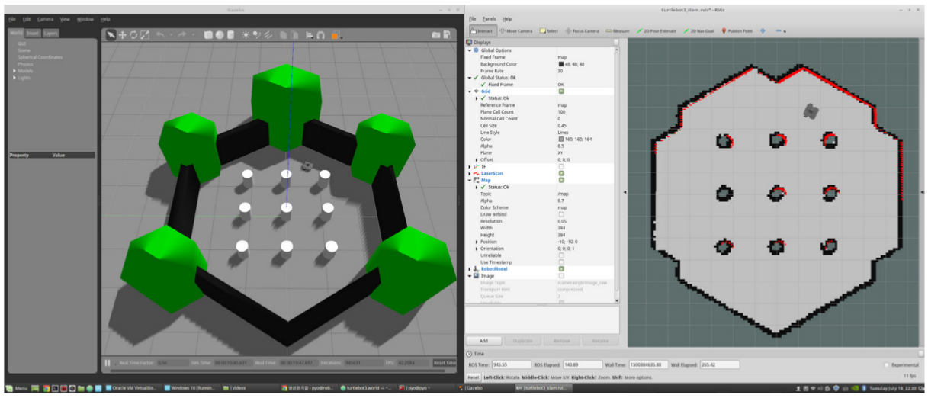
When the map is created successfully, open a new terminal and enter:
rosrun map_server map_saver -f ~/map
This command saves the map in two files: map.pgm and map.yaml
These map files will be used for the navigation.
Terminate all applications in all terminals with Ctrl+C.

Navigation simulation
If you have running applications in terminals, terminate all applications in all terminals with Ctrl+C.
- Start the simulation:
export TURTLEBOT3_MODEL=burger
roslaunch turtlebot3_gazebo turtlebot3_world.launch
- Run Navigation node
Open new terminal and enter the commands:
export TURTLEBOT3_MODEL=burger
roslaunch turtlebot3_navigation turtlebot3_navigation.launch map_file:=$HOME/map.yaml

- Estimate Initial Pose
Initial Pose Estimation must be performed before running the Navigation as this process initializes the AMCL parameters that are critical in Navigation. TurtleBot3 has to be correctly located on the map with the LDS sensor data that neatly overlaps the displayed map.
- Click the 2D Pose Estimate button in the RViz menu.
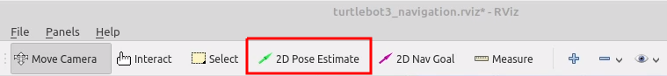
- Click on the map where the actual robot is located and drag the large green arrow toward the direction where the robot is facing.
- Repeat step 1 and 2 until the LDS sensor data is overlayed on the saved map.
- Launch keyboard teleoperation node to precisely locate the robot on the map.
roslaunch turtlebot3_teleop turtlebot3_teleop_key.launch
- Move the robot back and forth a bit to collect the surrounding environment information and narrow down the estimated location of the TurtleBot3 on the map which is displayed with tiny green arrows.
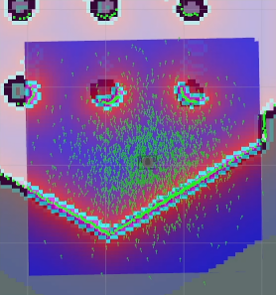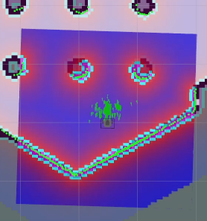
- Terminate the keyboard teleoperation node by entering Ctrl+C to the teleop node terminal in order to prevent different cmd_vel values, published from multiple nodes during Navigation.

- Set Navigation Goal
- Click the 2D Nav Goal button in the RViz menu.
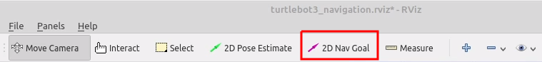
- Click on the map to set the destination of the robot and drag the green arrow toward the direction where the robot will be facing.
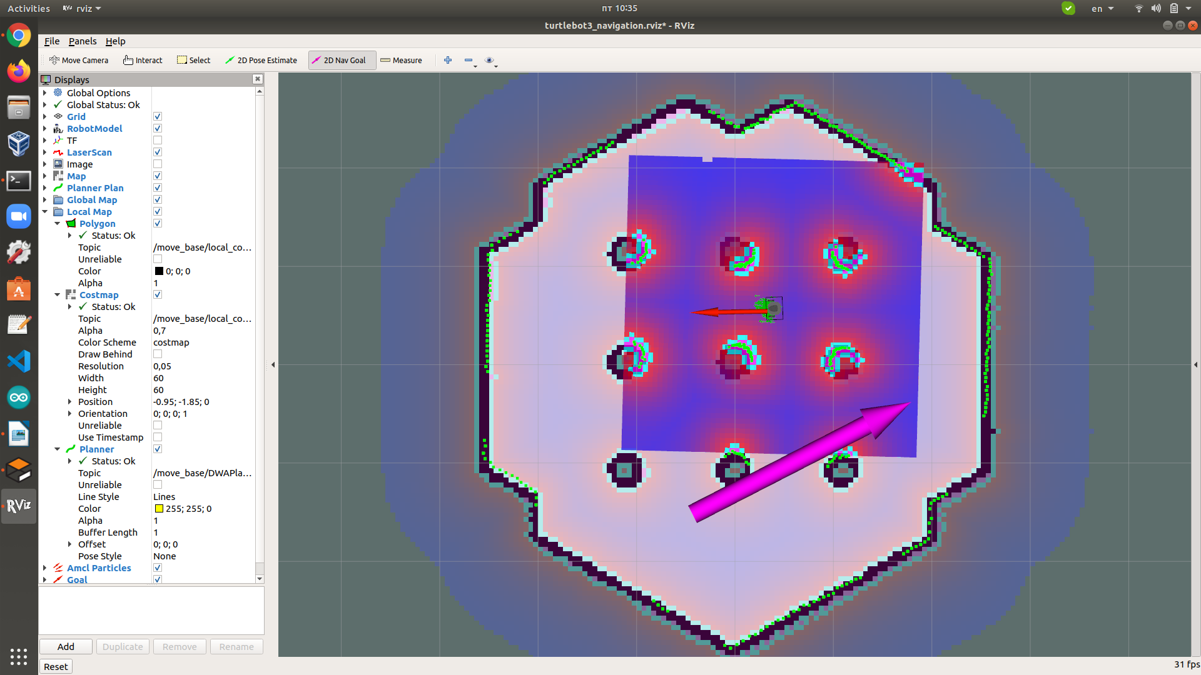
Wait till the robot reach the desired destination.
An example for Turtlebot3 Navigation is available in: https://www.youtube.com/watch?v=VYlMywwYALU&ab_channel=ROBOTISOpenSourceTeam

